Highly Rated…
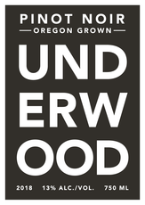
“Grapes for this humble Pinot are sourced
from all over the state. Such diversity is un-
heard of in a budget wine, as is aging in 15%
new French oak, also part of the process.
Pretty cherry and brambly blackberry fruit
shines most of all, with an elegant transparency.
It’s a light and almost delicate wine, but offers
sensational value and plenty of flavor.”
-Wine Enthusiast
90

Highly Rated…
“Grapes for this humble Pinot are sourced
from all over the state. Such diversity is un-
heard of in a budget wine, as is aging in 15%
new French oak, also part of the process.
Pretty cherry and brambly blackberry fruit
shines most of all, with an elegant transparency.
It’s a light and almost delicate wine, but offers
sensational value and plenty of flavor.”
-Wine Enthusiast
90

